Patent search:

[Intelligent web-enabled plant growing system and method of growing plant](http://patft.uspto.gov/netacgi/nph-Parser?Sect1=PTO2&Sect2=HITOFF&u=%2Fnetahtml%2FPTO%2Fsearch-adv.htm&r=1&p=1&f=G&l=50&d=PTXT&S1=10631469&OS=10631469&RS=10631469)

[Google Patents Link](https://patents.google.com/patent/US10631469B2/en?oq=10%2c631%2c469) (Has more pictures)

US Patent Number : 10,631,469

Description:

* Controls environmental conditions
* Photos taken periodically→ uploaded to server→ use AI to monitor growth and tells computer how the modify growing environment
* User application on PC/mobile reports state, allows user to buy seeds,make/upload recipes, and share though in-app social media

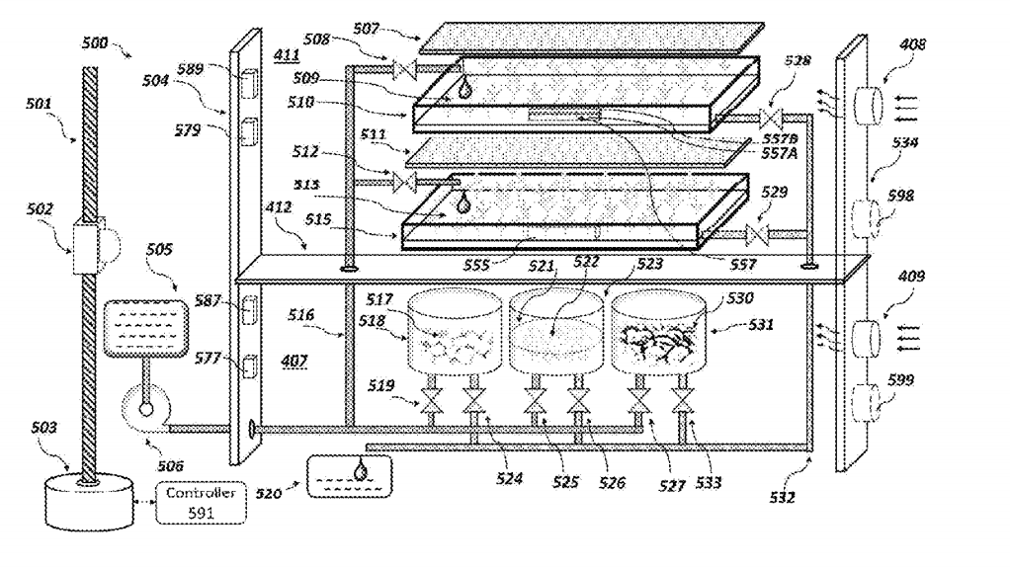

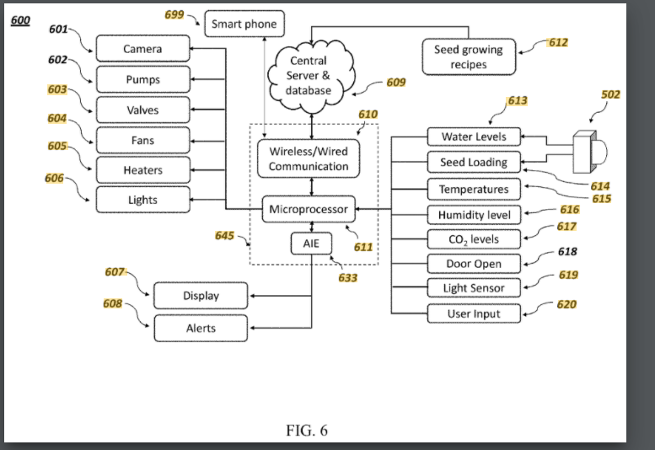

<https://patents.google.com/patent/US20160212954A1/en>

The system is independent of any kind of weather because it has an internal and external insulation. Indoor temperature also is regulated by a cold-heat exchanger. The lighting system will control the growth and function depending on the program used for each particular crop.

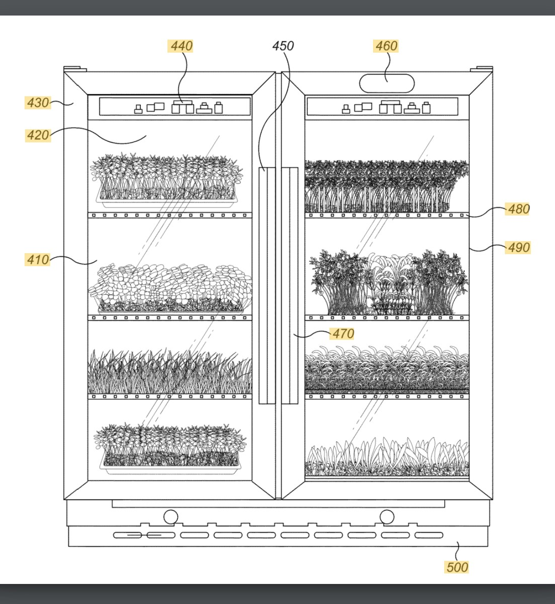

## US20160212954A1

<https://patents.google.com/patent/US4144671A/en>

This invention relates to means for germinating bean seed and developing bean sprouts therefrom, and more particularly to a self-watering bean sprout growing apparatus suitable for home-growing high quality bean sprouts in a quantity sufficient to supply the needs of the average family.

* Expired in 2011
* The apparatus automatically wets the germinated bean seeds and developing bean sprouts with fresh water that is uniformly distributed over the sprouting chamber at the predetermined interval, throughout the entire growing period. The water drains freely from the sprouts and leaves the growing tray through a discharge opening in its bottom. This prevents the seeds and partly developed bean sprouts from "drowning" or rotting which is caused by prolonged submergence.

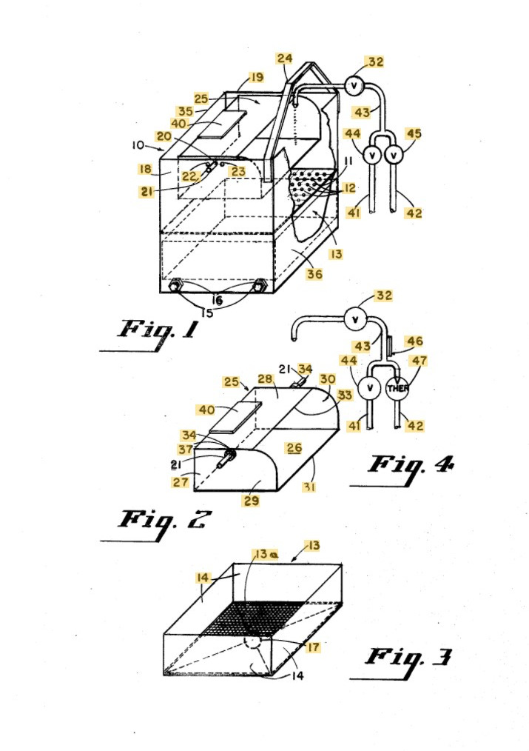

## US20160212954A1

## US20160212954A1

[Aeroponic commercial plant cultivation system utilizing a grow enclosure](http://patft.uspto.gov/netacgi/nph-Parser?Sect2=PTO1&Sect2=HITOFF&p=1&u=%2Fnetahtml%2FPTO%2Fsearch-bool.html&r=1&f=G&l=50&d=PALL&RefSrch=yes&Query=PN%2F9241453)

Patent Number :9,241,453

Aeroponic System

Good diagram to show what we haven't thought about

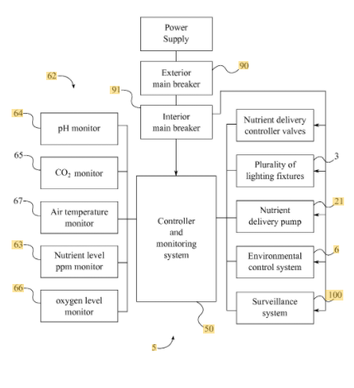

<https://hackaday.io/project/168342-microwth-automated-microgreen-farm> (not a patent, just cool)

Project goals:

There are a couple of project goals that we have in mind and are listed below:

* Design reliable standalone hardware to control lights and watering
* Good looking design that is easy to produce and functional
* Multiple size for different needs
* Software for offline functionality
* Software for online functionality
* Web app to manage Microwth farm(s) and have greater control over the process
* Create grow cycles for different types of plants

